GET REAL DOG TRAINING PRESENTS: A No Bullshit, Results-Driven Guide to the Science Behind How Dogs Learn
GET REAL DOG TRAINING Copyright 2018

Learning Theory 101:
Creating Canine Communication; How You and Your Dog Learn

Learning Theory 101:
How Your Dog Learns is the Same Way You Learn

Classical Conditioning
A learning process that occurs when two stimuli are repeatedly paired: a response which is at first elicited by the second stimulus is eventually elicited by the first stimulus alone. Also known as Pavlovian Conditioning.
(Example: A dog hears a bell, salivates at the sight of food, then is fed. After enough repetitions the dog hears the bell and salivates even when no food is present.)

Operant Conditioning
Operant Conditioning, or Skinnerian Conditioning, modifies behavior via positive and negative reinforcement. Through operant conditioning, an individual makes an association between a behavior and a consequence. It is the learning of cause and effect.
(Example: A dog is asked to sit, sits and is given a treat. A dog is asked to sit, does not sit, and it given a tap on the leash also known as a leash correction.)
There are four ways operant conditioning can occur, commonly referred to as operant conditioning quadrants. On the next page, you will get a more detailed look at the quadrants.
To train your dog we will pull a little bit from each category so that your dog learns what behaviors are acceptable, as well as what behaviors are not acceptable. This is sometimes called “balanced training” and we believe this is key to having a truly trained dog. If you only reward the behaviors you want to occur more often, and simply ignore the unwanted behaviors, you will likely have a bratty dog that only listens when they want to or when the surrounding stimulus is less interesting than their reward.

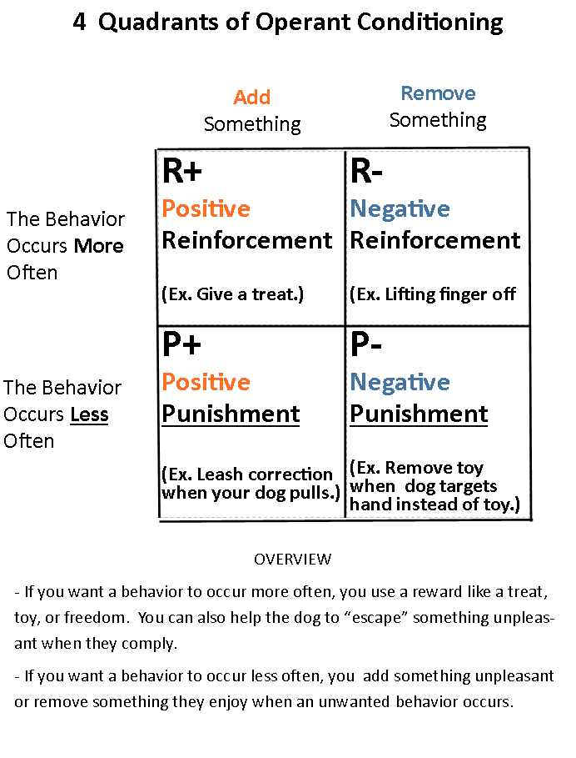

Marker Training
At Get Real Dog Training, we use a system of conditioning called marker training. This means that we will use a pre-selected word to mark the exact moment a behavior that we have asked for has occurred. For example, I tell the dog to sit, as soon as it’s butt hits the ground, I say “good”, then I give the dog a treat. It sounds simple but in dog training, timing is everything. Here is a chart to help you to get the timing just right:
“Sit” “Good” REWARD!
COMMAND MARKER WORD FEED THE DOG A TREAT

Types of Markers
Stationary Marker: A word that tells your dog to keep doing what you are doing, and good things will happen. I generally use “GOOD”.
Release Marker: A word that tells your dog to move out of a command or position and they will be rewarded. I generally use “YES”.
Free or Release Word: A word that means your dog is free to move. Generally, I use “OKAY”. The only reward given is freedom to move.

Charging Your Markers
Since we are teaching a new verbal language to a different species that mostly relies on body language or non-verbal communication to communicate, your dog won’t inherently know what these words mean. To get them on the same page, we will have to “charge” our marker words. Think of these terms that we must add value to as if they are rechargeable batteries. We will have to practice the word and what it means, independently of asking them for a command (another word or words that they do not yet know) to create our system of learning. It’s kind of like when we first learned to speak; you started with some sounds that formed into words, but true communication skills only developed with the introduction of grammar. To help you master this skill, your trainer will show you how to charge a marker and may have you start every session practicing this until both you and your dog are clear on the meanings of each marker.

